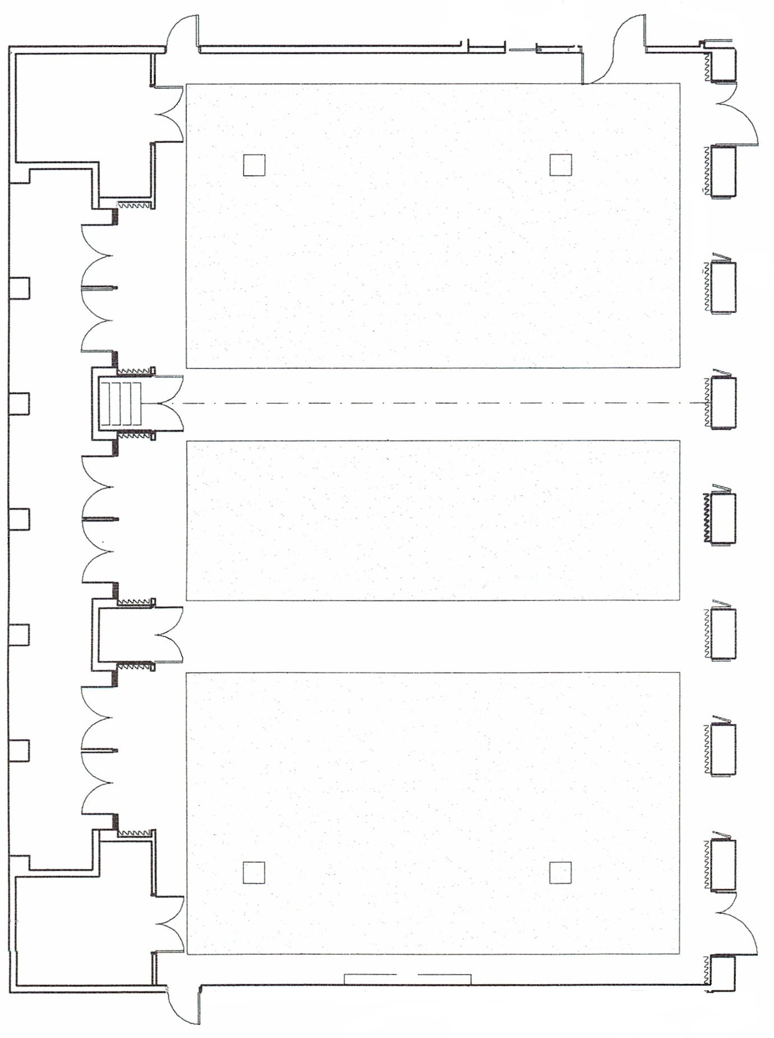

14’7”

15’2”

14’8”

7’2”

15’2”

7’1”
Screen

52’6”

15’2”

15’

8’7”

Terrace

15’2”
To Floral Display Hall
Ceiling height in this area inside dashed lines 11’
Ceiling height outside dashed lines 9’11”

26’11”
9’6”
11’8”
Great Hall-Visitor and Education Center – Lauritzen Gardens
North

